**EXP:- DESIGN AN LED FLASHER**

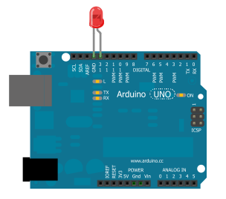

**In this project, we will go over how to build an arduino LED flasher circuit.**

**We will use a standard arduino board, doesn't matter which, and connect it so that it flashes an LED a certain amounts of times on and off repeatedly to create an LED flasher circuit.**

**An arduino is a self-contained microcontroller. Therefore, it can be programmed via the language Processing to turn the LED on for a certain period of time and turn it off for a certain period of time- over and over. To control the amount of time the LED will be on and the amount of time it will be off can easily be decided by our software code.**

**Once the arduino board is connected to a computer via USB, it has 5V of power. It gets power via the USB. The LED is then connected to its digital output pin. All we must then do is write our program which flashes the LED on and off.**

* **Components Needed**
* Arduino Board
* LED
* USB Connector

The arduino board can be any of several. It can be an arduino uno, duemilanove, etc.

The 5 volts of power, again, comes from the USB connection from the arduino board to the computer.

The USB connector that needs to be used is one which has a USB type A connector on one side and a Type B connector on the other

.

* **Arduino LED Flasher Circuit**

To build this circuit, we simply connect the anode of the LED (the longer of the 2 ends) to digital pin 13 of the arduino board and the cathode of the LED to the ground Pin of the arduino board.

The circuit connected will look like this

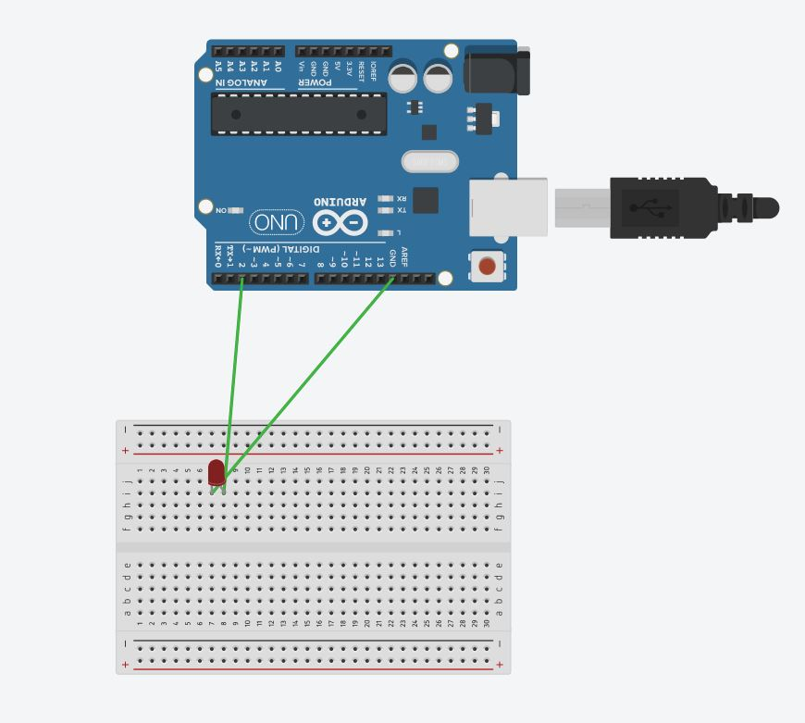

Once the circuit is connected in this way, all we have to do is take the USB connector and plug the type A connector into the computer and the type B connector into the arduino board.

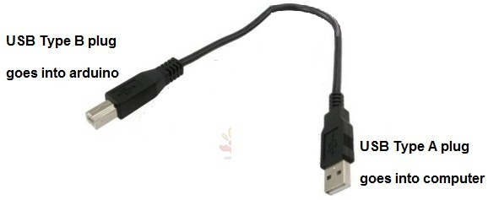

The USB type A connector goes into the computer which will program the arduino and the USB type B connector goes into the arduino board. Now the arduino has direct connection to the computer and can be programmed. Arduinos are programmed via USB connections

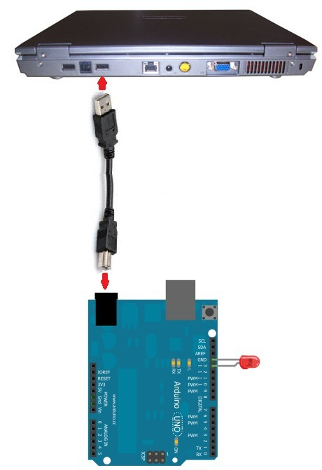

The last stage now is to write and then run the code which will make the LED connected to the board flash on and off.

* **Arduino LED Flasher Code**

The code needed to flash the LED on the arduino board is shown below.

**Program or codeing:**

//Flashing LED Circuit

const int LED= 13;//LED connected to digital pin 13

void setup()

{

pinMode(LED, OUTPUT);

}

void loop()

{

digitalWrite(LED,HIGH); //turns the LED on

delay(1000); //waits for a second

digitalWrite(LED,LOW); //turns the LED off

delay(1000); //wait for some second

This code above turns the LED on and off. It turns the LED on, waits a second, then turns the LED off, and waits a second. Therefore, the LED blinks or flashes every second. The 1000 value is specified in milliseconds (ms). Since 1000 milliseconds equals 1 second, this is the commands that the arduino follows. You can adjust this value to suit your needs. If you want the LED to flash quicker or more frequently, then you would decreased the delay() value. If you want the LED to flash slower, then you would increase the delay() value.

* **Learning & Observation :**

1. *Observed Blinking of LED.*
2. *Working of Arduino.*
3. *Different sections of Arduino.*

4.Coding for Arduino to blink a LED

**Precautions:**

1. **There should not be any loose connection in the circuit.**
2. **Code should be written properly.**
3. **Arduino should be attached to pc/laptop properly.**